

Comcast telecom consumer complaints

Thobelani Mkhize



September 26, 2019

=== **Importing Comcast_telecom_complaints Data in to the SAS Studio** ===

FILENAME REFFILE '/folders/myfolders/Comcast_telecom_complaints_data.csv';

PROC IMPORT DATAFILE=REFFILE

DBMS=CSV

OUT=WORK.Complaints;

GETNAMES=YES;

RUN;

================ **Question one** ===================

**Code:**

**-Series Plot**

ods graphics / reset width=6.4in height=4.8in imagemap;

proc sort data=WORK.COMPLAINTS out=_SeriesPlotTaskData;

by Date_month_year;

run;

proc sgplot data=_SeriesPlotTaskData;

series x=Date_month_year y=Ticket__ / group=Customer_Complaint curvelabel

curvelabelpos=max;

xaxis grid;

yaxis grid;

run;

ods graphics / reset;

proc datasets library=WORK noprint;

delete _SeriesPlotTaskData;

run;

**Result:**

-Trend Chart for the number of complaints Using the Series plot.

-I used Two variables, Date_Month_Year in my x-axes and

Ticket Number as my y-axes That is assigned to each and every Complaint

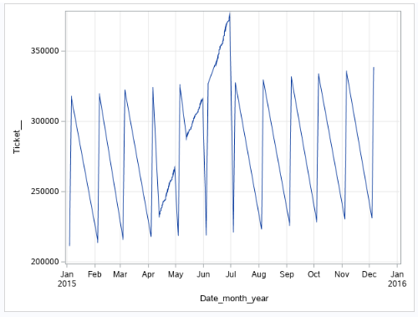

**-Histogram**

ods graphics / reset width=6.4in height=4.8in imagemap;

proc sgplot data=WORK.COMPLAINTS;

histogram Date_month_year / scale=count;

yaxis grid;

run;

ods graphics / reset;

**Result:**

-We can also use Histogram to draw Trend Chart for the number of complaints.

Making our x-axes to be Date_Month_Year and,

setting our Y-axes to be on count scale that will count the number of complaint in each Month Daily.

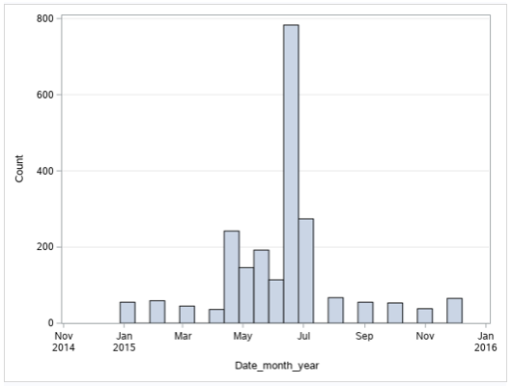

================ **Question Two** ================

**Code:**

Proc sort data=work.complaints;

by Customer_Complaint;

Run;

Proc Freq Data=work.complaints;

Table Customer_Complaint;

title 'Frequence Table';

Run;

**Result:**

-Firstly i sorted the data using the procedure sort.

-Then after I used the Freq Procedure in order to get the table that contains the frequency of complaint type.

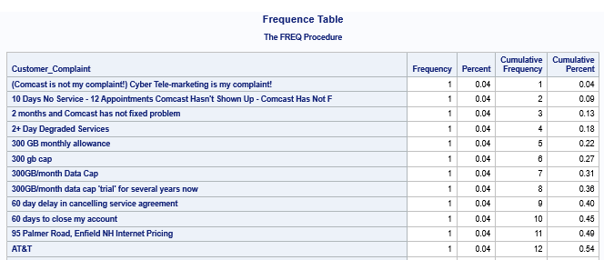

**The Maximum Complaint type**

Proc Freq Data=work.complaints;

Table Received_Via;

Run;

**Result:**

-I used the Proc Freq, in order to get the maximum complaint type.

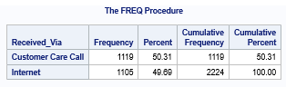

=============== **Question Three** ==============

**Code:**

Data ComplaintsOpenClosed;

Set Complaints;

Length NewStatus $8.;

if Status = "Open" Then

NewStatus = "Open";

else if Status = "Pending" Then

NewStatus = "Open";

else

NewStatus = "Closed";

Run;

Proc Print Data= Complaints;

Run;

Proc Print Data=ComplaintsOpenClosed;

Run;

**Result:**

-The conditional statement, If then Else is the one that helped me to create the new Categorical Variable between Open and Closed observations to replace the Pending and Solved observations.

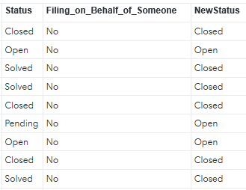

================ **Question Four** ==================

**Code:**

ods graphics / reset width=9in height=4.8in imagemap;

proc sgplot data=WORK.COMPLAINTSOPENCLOSED;

vbar State / group=NewStatus groupdisplay=stack stat=percent;

yaxis grid;

run;

ods graphics / reset;

**Result:**

-The stacked bar chart shows that the State of Georgia have the:

* Maximum Complaint.
* The highest percentage of unresolved complaints.

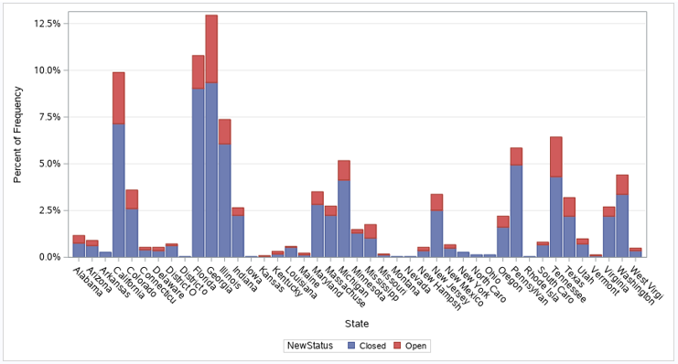

============ **Question Five** ==================

**Code:**

Proc sort data=ComplaintsOpenClosed;

By Date;

Run;

Proc Freq Data=ComplaintsOpenClosed;

Table NewStatus*Received_Via;

Run;

**Result:**

-I stated by sorting the dataset ComplaintsOpenClosed using Procedure Sort

-I then use Procedure Freq to get the percentage of complaints resolved till date, using two variables, NewStatus and Received_Via

